# Durable Furnitures

Noir

## Corner TV Stand 54inches

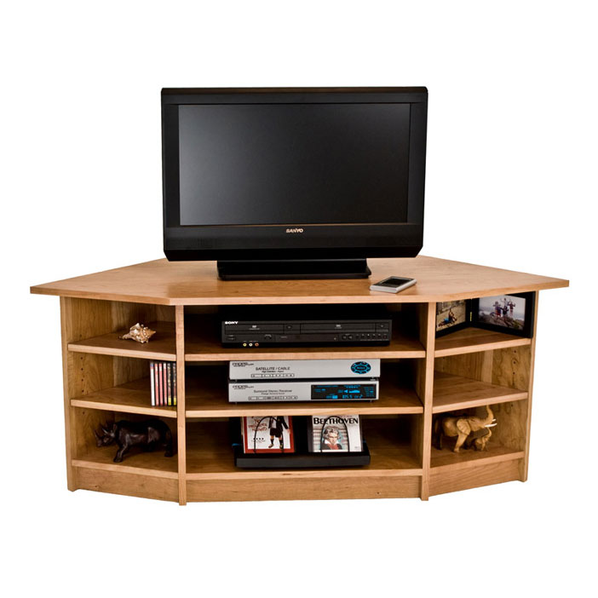

Our Corner TV-Media Stand is handmade in Vermont and can be customized for your flat screen TV size! Our solid hardwood is sustainably harvested making it a beautiful and responsible choice. This TV-Entertainment Center has a modern look, and will fit perfectly into any corner of your home!